|  |  |
| --- | --- |
|  | www.americanosp.com/index.php/AiE ISSN: 19XX-34XX (Print) ISSN: 19XX-34XX (Online)  **Advances in Eye**  *DOI: https://doi.org/10.70122/AiE12345678* |

**Title of Paper Less Than 15 Words with Selected Words Reflected the Theme of the Study (Palatino Linotype Bold 12 pt)**

First author1*,Second author2, Third author3 (Palatino Linotype 10 pt)

*1First author affiliation, University/Institute; First author Email address, ORCID. (Palatino Linotype 8 pt)*

*2Second author affiliation, University/Institute; Second author Email address, ORCID. (Palatino Linotype 8 pt)*

*3Third author affiliation, University/Institute; third author Email address, ORCID. (Palatino Linotype 8 pt)*

*\*Corresponding Author email: abc@gmail.com*



|  |  |
| --- | --- |
| Paper type:  Research paper, Review paper, Case study, Commentary  Received 01 January 2024  Revised 12 February 2024  Accepted 25 February 2024 | **Abstract**  Papers exploring the intersections of business, science, and philosophy are welcomed. The abstract, restricted to 200 words, should outline the problem definition, underlying assumptions, methodology, summary of findings, and a clear statement of the study's objective, results, and conclusion within the realm of business science philosophy. (Palatino Linotype 8 pt)  Keywords: first keyword, second keyword (Maximum five keywords) (Palatino Linotype 8 pt) |

**1. Introduction** (Palatino Linotype 10 pt, Bold)

The introduction ought to provide a concise overview of the study's broader context and emphasize its significance. It should elucidate the purpose of the work and underscore its importance. A thorough review of the current state of research in the field is essential, including references to key publications. When applicable, controversial and diverging hypotheses should be highlighted. Additionally, briefly outlining the main objective of the study and emphasizing its principal conclusions is imperative. It is advisable to maintain clarity in the introduction to ensure it is comprehensible to scientists outside the specific field of research (Palatino Linotype 10 pt).

**2. Materials and Methods** (Palatino Linotype 10 pt, Bold)

The Materials and Methods section should be sufficiently detailed to enable others to replicate and expand upon the published findings. Upon publication, you are obligated to make all materials, data, computer code, and protocols associated with the manuscript available to readers. Any restrictions on the availability of materials or information should be disclosed at the submission stage.

For new methods and protocols, provide a thorough description, while well-established methods can be summarized and appropriately cited. Research manuscripts with large datasets deposited in a publicly available database should specify the data deposition location and provide relevant accession numbers. If accession numbers are not yet available at submission, indicate that they will be provided during the review process. However, they must be supplied before publication.

Intervention studies involving animals or humans, and other studies requiring ethical approval, must disclose the approving authority and the corresponding ethical approval code.

**3. Results** (Palatino Linotype 10 pt, Bold)

This section can be organized into subheadings for clarity. It should offer a succinct and accurate account of the experimental results, their interpretation, and the conclusions drawn from the experiments.

3.1. Subsection

3.1.1. Subsubsection

Bulleted lists appear as follows:

* First bullet;
* Second bullet;
* Third bullet.

Numbered lists are formatted as:

1. First item;
2. Second item;
3. Third item.

The narrative continues below.

**3.2. Figures, Tables, and Schemes**

All figures and tables referenced in the main text should be sequentially numbered as Figure 1, Table 1, etc.

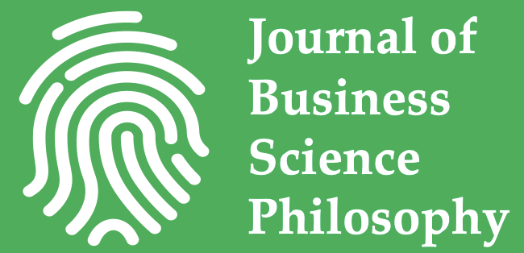

Figure 1. This is a model or figure used in the study.

Table 1. This is a table about the results. (APA style of table format)

|  |  |  |  |
| --- | --- | --- | --- |
| Column 1 | Column 2 | Column 3 | Column 4 |
| Row 1 | Row 1 | Row 1 | Row 1 |
| Row 2 | Row 2 | Row 2 | Row 2 |

This is an example of equation.

a = b + c + d + e + f + g + h + i + j + k + l + m + n + o + p + q + r + s + t + u + v + w + x + y + z (1)

$B_{y}= \left\{H\left(y-y_{1}+\frac{μ}{2}\right)-H\left(y-y_{1}-\frac{μ}{2}\right)\right\}$ (2)

**4. Discussion**

The results of the study and corresponding discussions are presented in this section.

**5. Conclusions**

The primary conclusions of the paper should be summarized in this section.

**Acknowledgment (Optional)**

Acknowledgments are included in this section.

**References**

References should be listed alphabetically in the list of references. In the text, references should follow the format (Author's Last Name, Year). The complete details of the references will appear in the list of references.

Here is an example of how to format different types of references in APA style:

1. Journal Article:

Author, A. A., Author, B. B., & Author, C. C. (Year). Title of article. Title of Periodical, volume number (issue number), pages. DOI or URL

Example:

Smith, J. D., Brown, K. L., & Johnson, M. A. (2019). The impact of leadership styles on employee motivation. Journal of Management, 25(3), 123-135. https://doi.org/10.1080/12345678.2019.1234567

2. Book:

Author, A. A. (Year). Title of work. Publisher.

Example:

Johnson, R. T. (2017). Strategic management: Concepts and cases. Pearson.

3. Website:

Author, A. A. (Year). Title of webpage. Website Name. URL

Example:

American Psychological Association. (2022). APA style. https://apastyle.apa.org/

4. Chapter in an Edited Book:

Author, A. A., & Author, B. B. (Year). Title of chapter. In A. Editor & B. Editor (Eds.), Title of book (pages of chapter). Publisher.

Example:

Davis, L. M., & Johnson, P. R. (2018). Human resource management in the digital age. In K. Smith & J. Brown (Eds.), Advances in management (pp. 45-67). Routledge.

Ensure consistency in formatting and punctuation throughout the reference list. For more detailed guidelines, please consult the Publication Manual of the American Psychological Association (7th ed.).